**Wipro Training process for Linux systems:**

**Day 1:**

**Task 1:**

**Difference between the single core, dual core, quad core, i5 and i7 processors:**

**Single core:**

In single core processor, handling one task at a time and it is limited multitasking processing and mainly it is depending based on their clock speed.

**Dual Core vs Quad Core:**

In a dual core handling the 2 tasks at a time and this processer is with two independent core on a single chip. Handling multiple performance applications in a single time and it is better performance than single core. Having performance in multi threaded applications. Mainly it is used for the small works like web browsing and small office working process. It is less power consumption than quad core and it is cheaper than quad core processors.

**Quad Core:**

In a dual core processor having the four independent cores in a single chip and it is allowing the performance tasks simultaneously. It is high performance than dual core and it is more cost than dual core. This processor is reflecting the enhanced performance and better multitasking capabilities. It is supporting the high gaming applications and running multiple demanding applications simultaneously. It is suitable for laptops and desktops for better performance than dual core.

**Compare between i5 vs i7:**

**I5:**

In contemporary models, i5 CPUs typically contain 4–6 cores and 8–12 threads. There may be fewer threads in older models because hyper-threading wasn't always there. Intel Turbo Boost technology provides dynamic frequency scaling at base clock rates ranging from moderate to high. They are an excellent option for laptops and desktop computers when energy conservation is an issue because they are often more power-efficient than i7 CPUs. Perfect for regular users who require dependable performance for work-related tasks like emailing, using office software, and playing light games.

**I7:**

i7 processors typically feature 4–8 cores, 8–16 threads, and greater than i5 CPU base and increase clock rates. Greater cache capacities, usually between 8 and 16 MB, improve performance for jobs involving a lot of data. Better for demanding apps, sophisticated gaming, and intensive multitasking. increased power consumption compared to i5 processors, which can shorten laptop batteries but increase performance for heavy lifting. Ideal for professionals, gamers, and power users who require optimal performance for challenging and complicated activities.

**DAY 2:-**

**Network or Network id 192**

**Host**

**Class A : N.H.H.H**

**Class B : N.N.H.H**

**Class C : N.N.N.H**

|  |  |  |
| --- | --- | --- |
| /1 128 | 0 | 0 0 |
| /2 192 | 0 | 0 0 |
| /3 224 | 0 | 0 0 |
| /4 240 | 0 | 0 0 |
| /5 248 | 0 | 0 0 |
| /6 252 | 0 | 0 0 |
| /7 254 | 0 | 0 0 |

|  |  |  |  |  |
| --- | --- | --- | --- | --- |
| /18 | 255 | 0 | 0 | 0 |
| /19 | 255 | 128 | 0 | 0 |
| /10 | 255 | 192 | 0 | 0 |
| /11 | 255 | 224 | 0 | 0 |
| /12 | 255 | 240 | 0 | 0 |
| /13 | 255 | 248 | 0 | 0 |
| /14 | 255 | 252 | 0 | 0 |
| /15 | 255 | 254 | 0 | 0 |
| /16 | 255 | 255 | 128 | 0 |
| /17 | 255 | 255 | 192 | 0 |
| /18 | 255 | 255 | 224 | 0 |
| /19 | 255 | 255 | 240 | 0 |
| /20 | 255 | 255 | 248 | 0 |
| /21 | 255 | 255 | 252 | 0 |
| /22 | 255 | 255 | 254 | 0 |
| /23 | 255 | 255 | 255 | 0 |
| /24 | 255 | 255 | 255 | 0 |
| /25 | 255 | 255 | 255 | 128 |
| /26 | 255 | 255 | 255 | 192 |
| /27 | 255 | 255 | 255 | 224 |
| /28 | 255 | 255 | 255 | 240 |
| /29 | 255 | 255 | 255 | 248 |
| /30 | 255 | 255 | 255 | 252 |
| /31 | 255 | 255 | 255 | 254 |
| /32 | 255 | 255 | 255 | 255 |

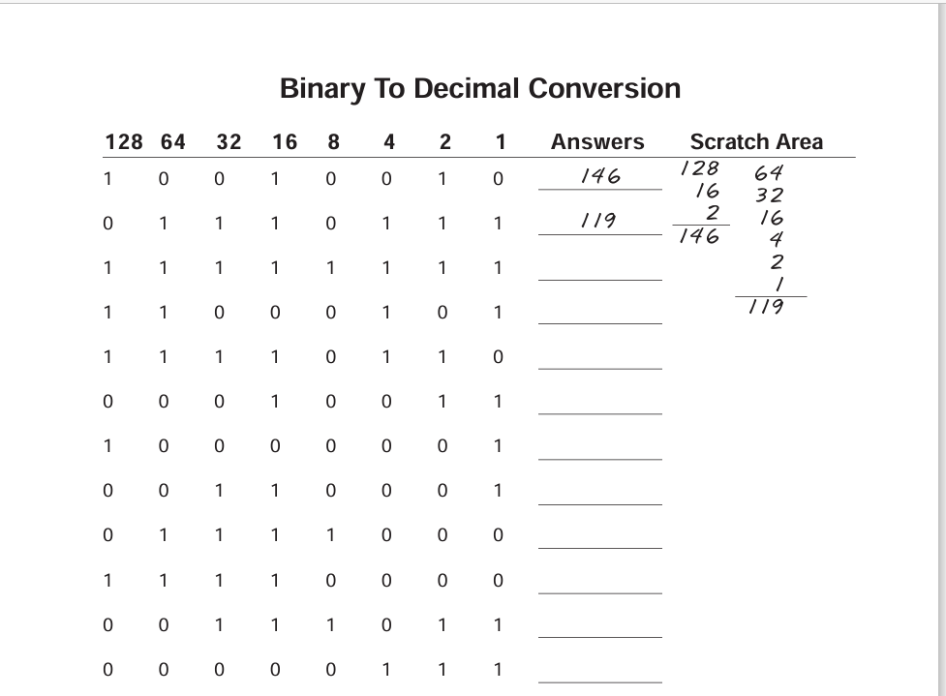

**ANSWERS:**

**255**

**197**

**246**

**019**

**129**

**049**

**120**

**115**

**059**

**007**

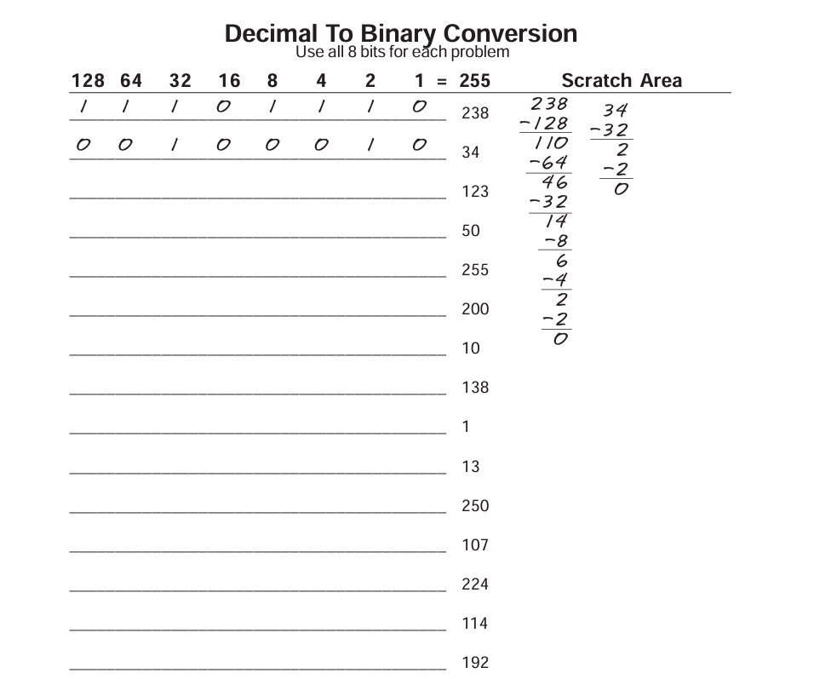

**ANSWERS:**

1111011

0110010

1111111

11001000

1010

10001010

0001

1101

11111010

1101011

11100000

1110010

11000000

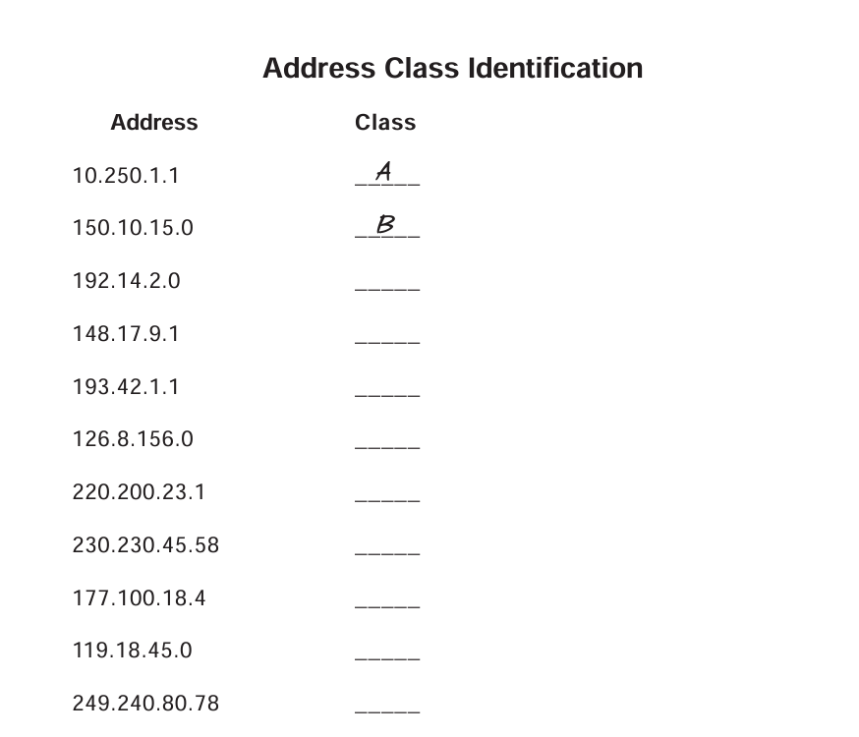

ANSWERS:

­­C

B

C

A

C

D

B

A

E

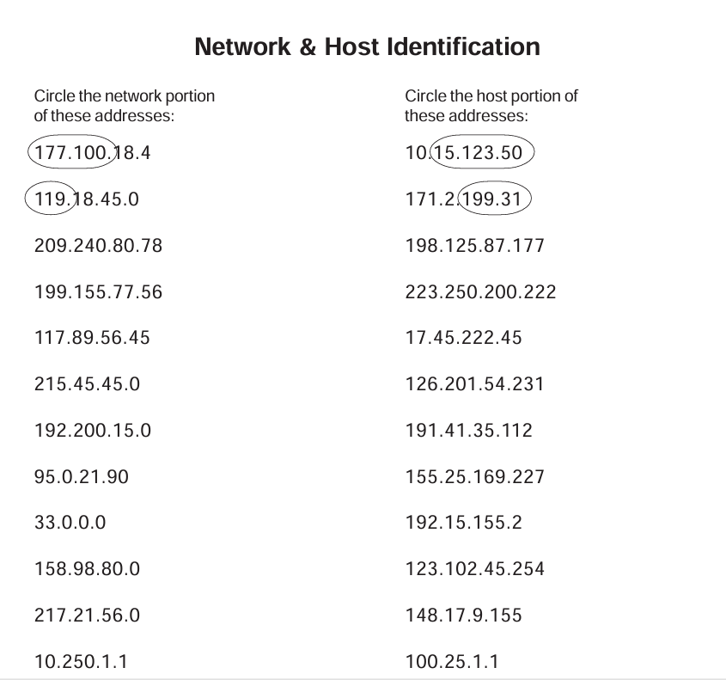

ANSWERS:-

209.240.80 177

199.155.77 222

117 45.222.45

215.45.45 201.54.231

192.200.15 35.112

95 169.227

33 2

158.98 102.45.245

217.21.56 9.155

10 25.1.1

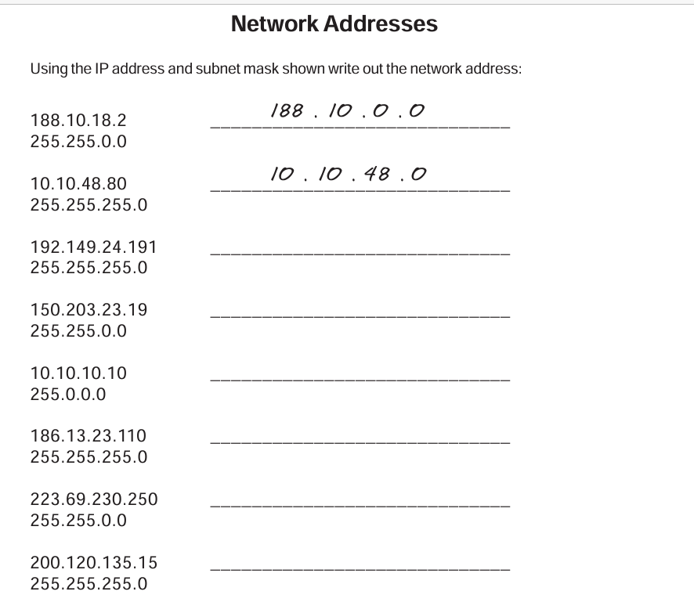

ANSWERS:-192.149.24.0

150.203.0.0

10.0.0.0

186.13.23.0

223.69.0.0

200.120.135.0

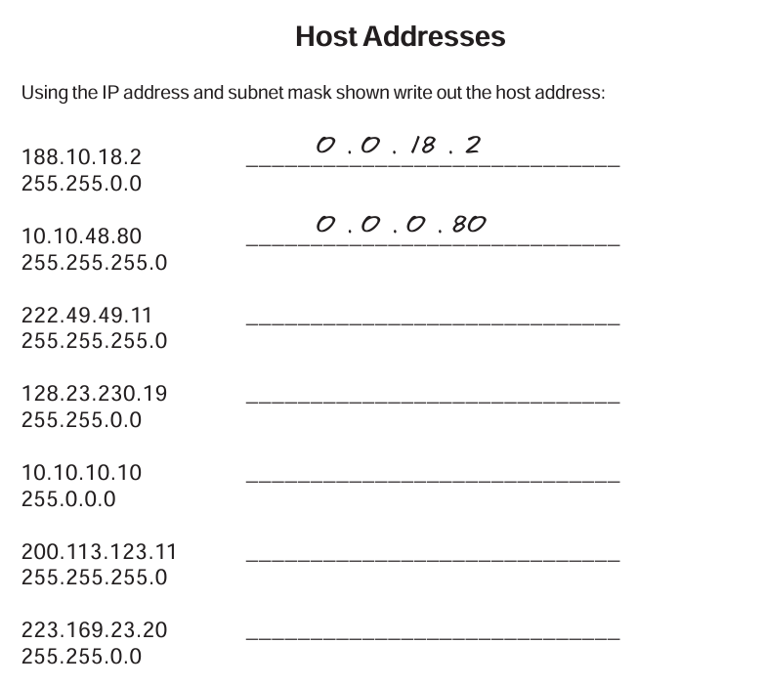

ANSWERS:-0.0.0.11

0.0.230.19

0.10.10.10

0.0.0.11

0.0.23.20

**Subnet 1IP:**

192.168.1.2

192.168.1.5

192.168.1.6

192.168.1.7

192.168.1.9

**Subnet 2 IP:**

**Day 3:**

**Activity 1:**

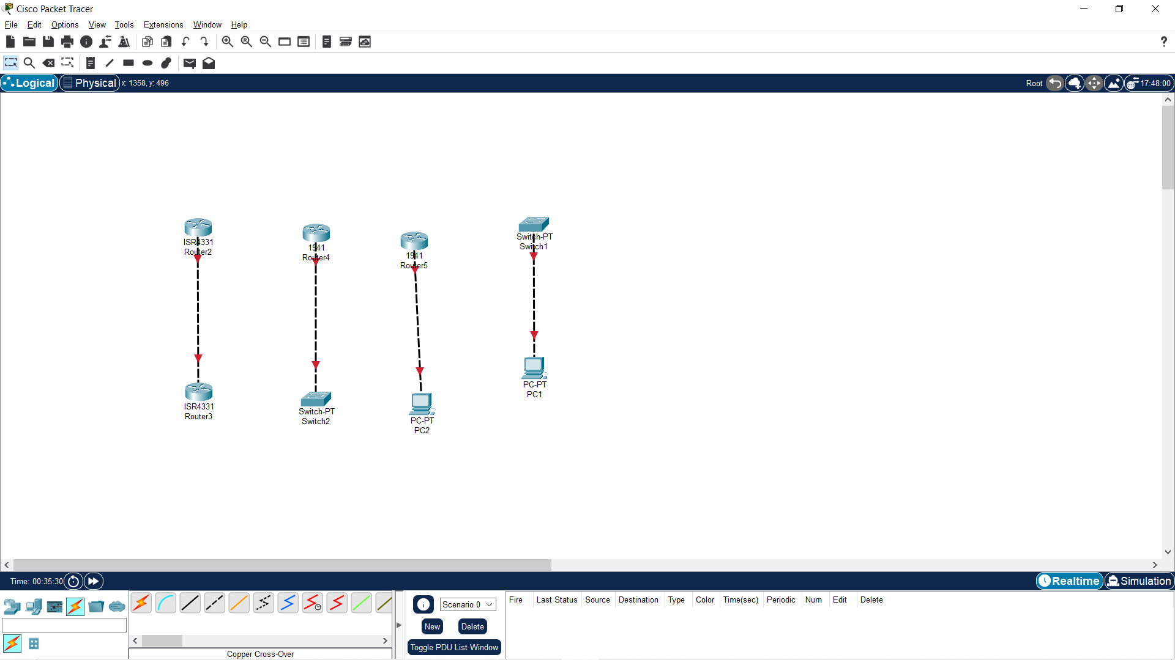

**Activity 2:**

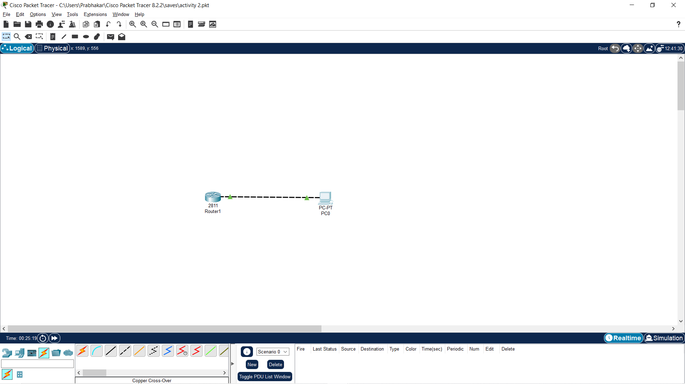

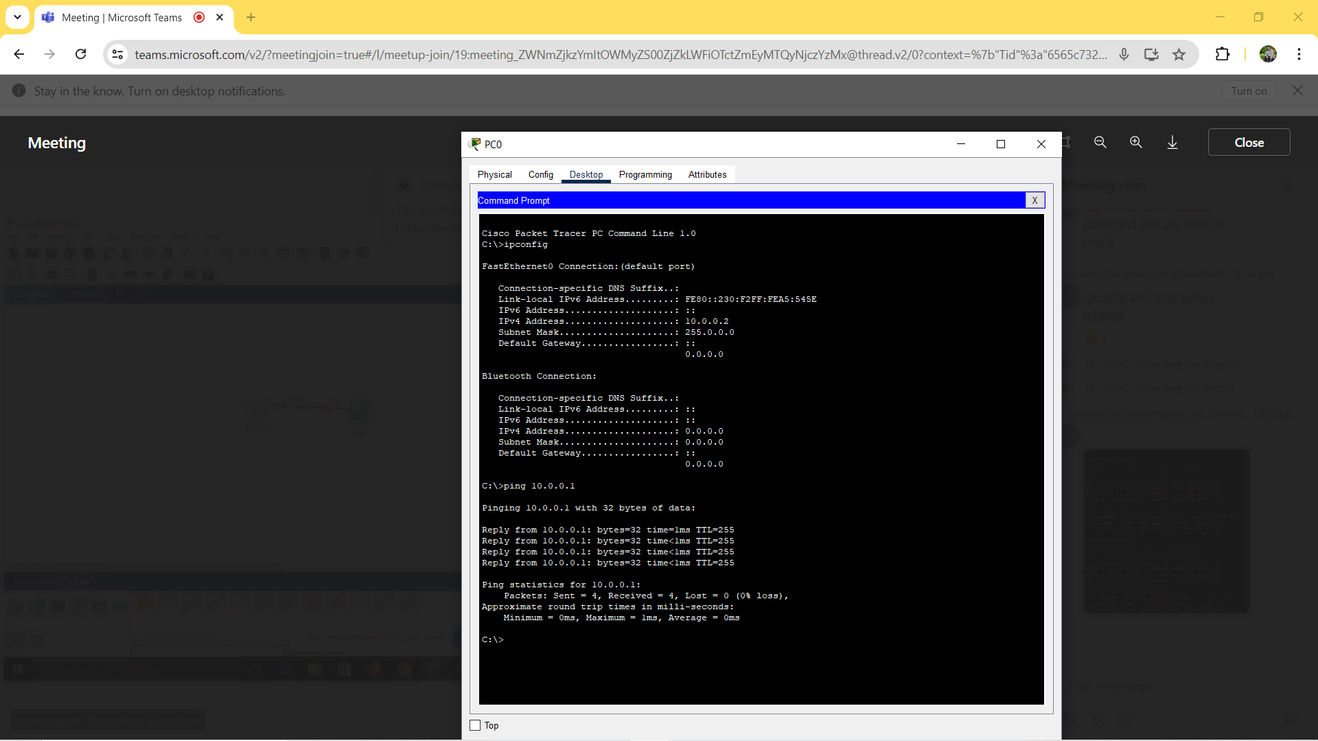

**Activity 3:**

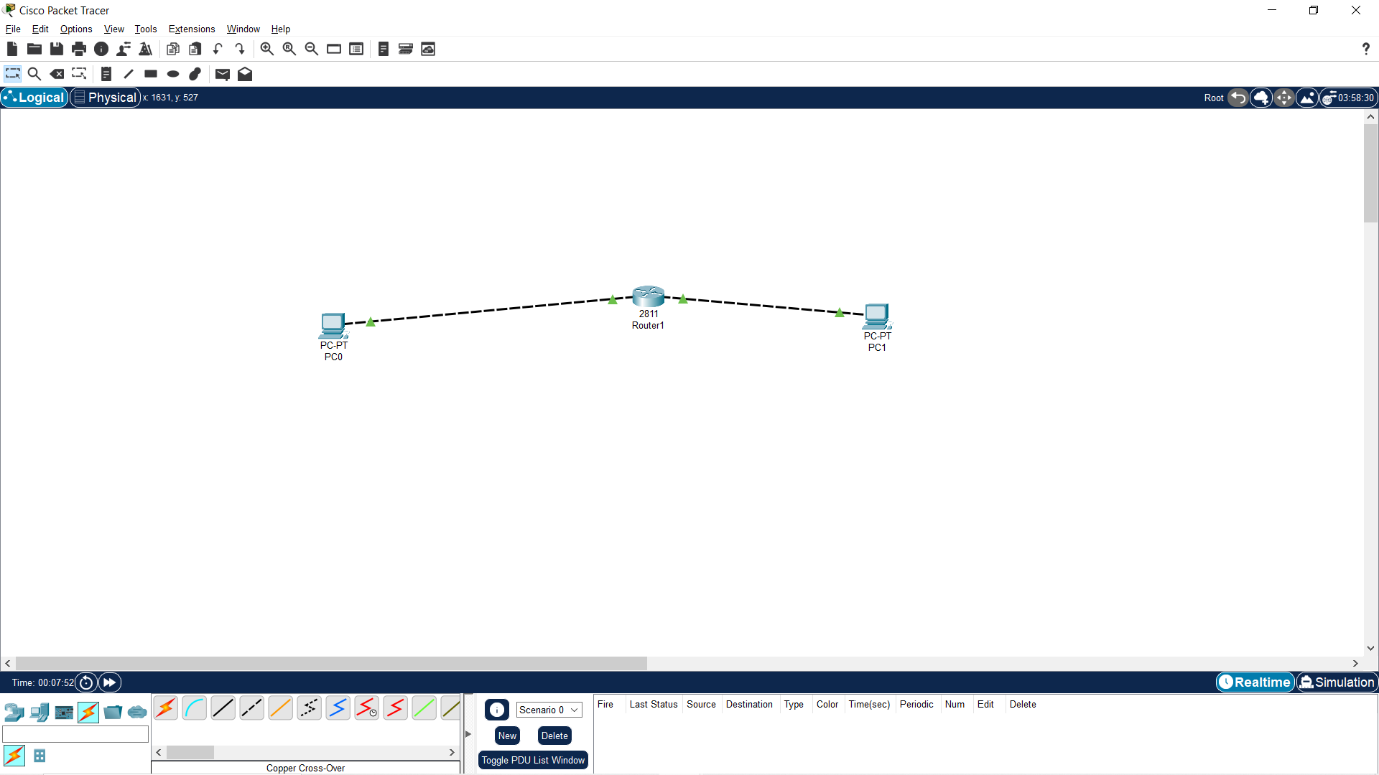

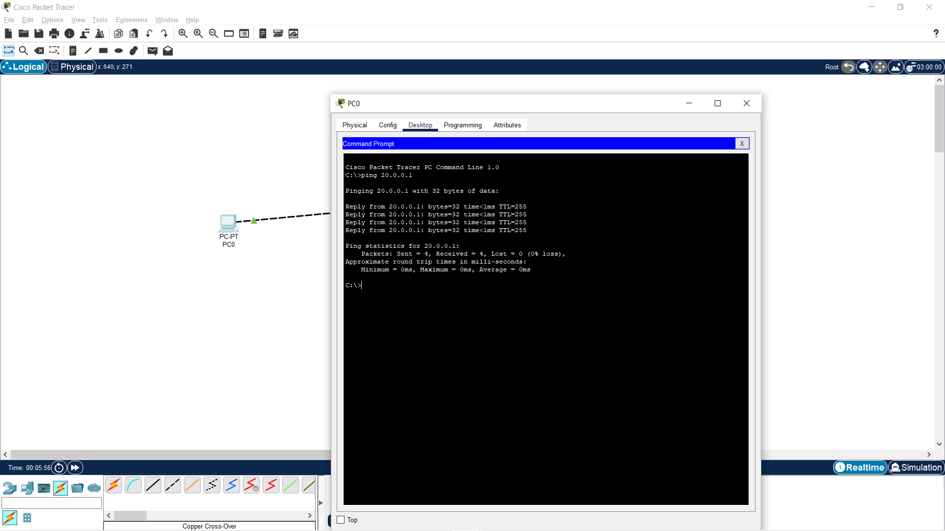

**Activity 4:**

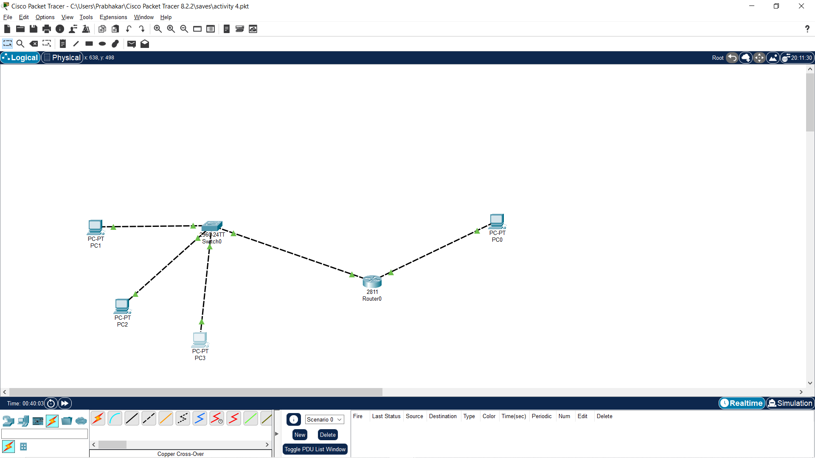

**Activity 5:**

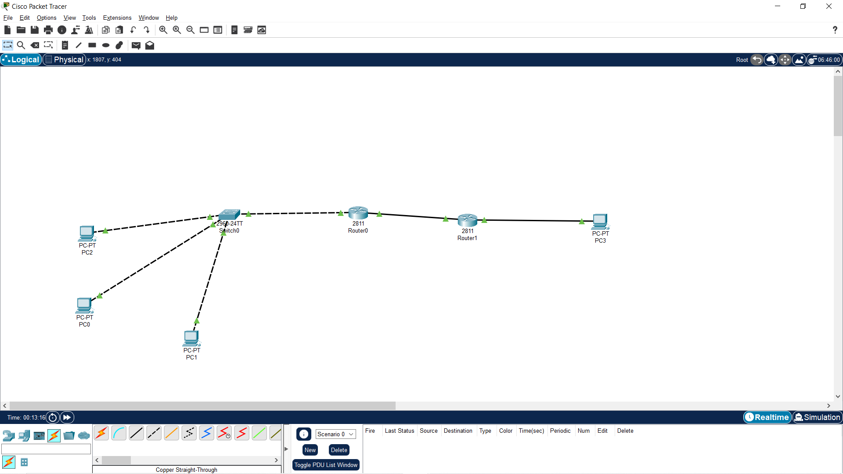

**Day 4:**

**Activity 1:**

**Static routing:**

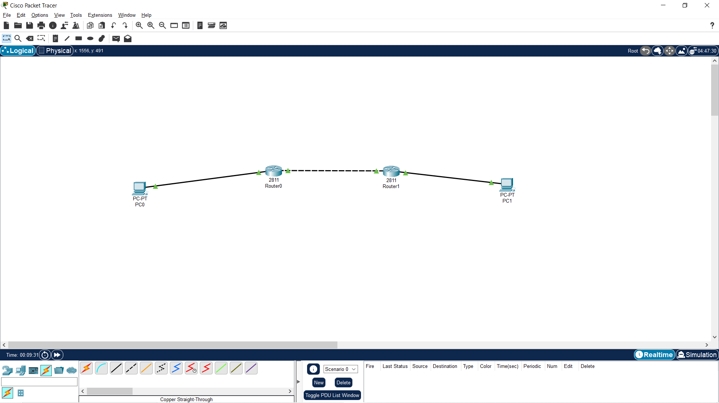

**Day 5:**

**Activity 1:**

**OSI vs TCP/IP:**

|  |  |
| --- | --- |
| **OSI** | **TCP/IP** |
| The application layer provides network services directly to end users (for example, HTTP and FTP). | The application layer reflects OSI Layers 5-7 (for example, HTTP and FTP). |
| The Presentation Layer is responsible for data translation, encryption, and decryption (for example, JPEG compression). | Transport Layer is Equivalent to OSI Layer 4 (e.g., TCP and UDP). |
| The Session Layer establishes, manages, and terminates sessions between applications. | Internet Layer is Similar to OSI Layer 3 (e.g., IP and ICMP). |
| The Transport Layer ensures that data is transferred reliably between devices (for example, TCP and UDP). | The Link Layer combines OSI Layers 1 and 2 (such as Ethernet and Wi-Fi). |
| Network Layer is Controls logical addressing, routing, and traffic control (e.g., IP). | Directly related to the development and functioning of the Internet. |
| The Data Link Layer coordinates data transfer via physical links (such as Ethernet). | Reduces the number of layers, making network design and troubleshooting easier. |
| The physical layer transmits raw data bits over a physical media (such as cables or fibers). | Provides flexibility and scalability in network designs. |
| Offers a straightforward and systematic approach to network design and troubleshooting. | Initially built with an emphasis on interconnecting various network technologies rather than precise protocol standards. |

**Activity 2:**

**OSI-MODEL: OPEN SYSTEMS INTERCONNECTIONS:**

|  |  |
| --- | --- |
| **Layer Name** | **Applications** |
| **Application Layer** | END USER LAYER HTTP,FTP,SSH,DNS,IRC |
| **Presentation Layer** | SYNTAX LAYER SSL,MPEG,JPEG,IMAP,MP3 |
| **Session Layer** | SYNCH & SEND TO PORT  APIS,SOCKETS,WINSOCK |
| **Transport Layer** | END-END CONNECTION  TCP,UDP |
| **Network Layer** | END-END CONNECTION TCP,UDP |
| **Data Link Layer** | FRAMES  ETHERNET,PPP,SWITCH,BRIDGE |
| **Physical layer** | PHYSICAL STRACTURE  COAX,FIBER,WIRELESS,HUBS |

**Activity 3:**

**LAYERS:**

|  |  |  |  |
| --- | --- | --- | --- |
| **Layers** | **Protocols** | **Port Numbers** | **services** |
| **Application** | HTTP,FTP, SMTP,POP3, IMAP, Telnet | HTTP (80), HTTPS (443), FTP (20, 21), SMTP (25), POP3 (110), IMAP (143), Telnet (23) | Email, web browsing, file transfer, remote login |
| **Presentation** | SSL/TLS, ASCII, JPEG, GIF, PNG | SSL/TLS (443), ASCII (7) | Data encryption, data compression, data formatting |
| **Session** | NetBIOS, PPTP, RPC | NetBIOS (137-139), PPTP (1723), RPC (Remote Procedure Call) | Session management, dialog control, synchronization |
| **Transport** | TCP, UDP | **TCP**-HTTP (80), HTTPS (443), FTP (20, 21), SMTP(25),POP3(110), IMAP (143),SSH(22), Telnet(23)  **UDP**-DNS(53),DHCP(67,68),SNMP(161), TFTP(69),NTP(123) | Reliable data delivery, error-checking, flow control |
| **Network** | IP, ICMP, ARP | ICMP (Internet Control Message Protocol), ARP (Address Resolution Protocol) | Logical addressing, routing, traffic control |
| **Data Link** | Ethernet, PPP, HDLC, LLC | **----------------** | Error detection and correction, framing |
| **Physical** | Ethernet, Wi-Fi, Fiber optics, USB, Bluetooth | **--------------------** | Physical transmission of data |

**Activity 1:**

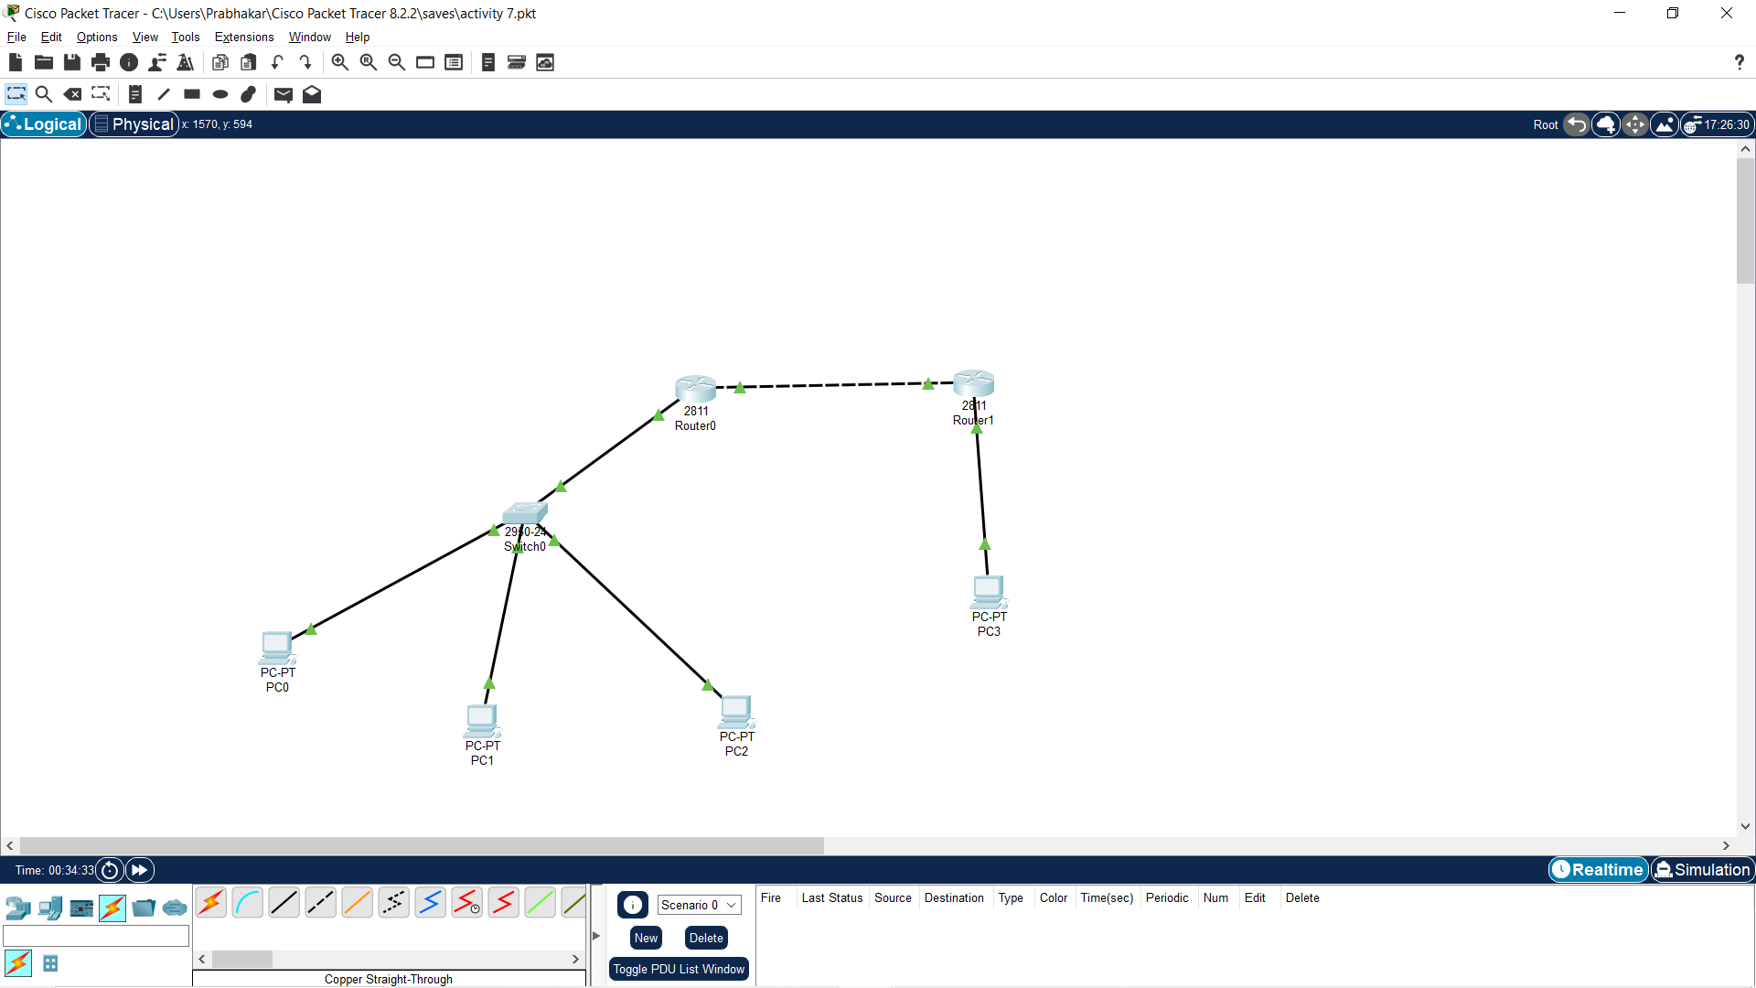

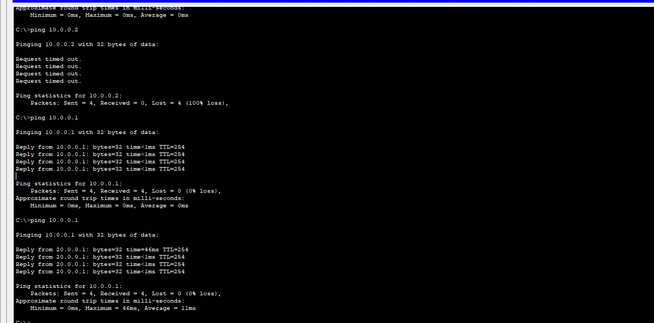

**Day 6:**

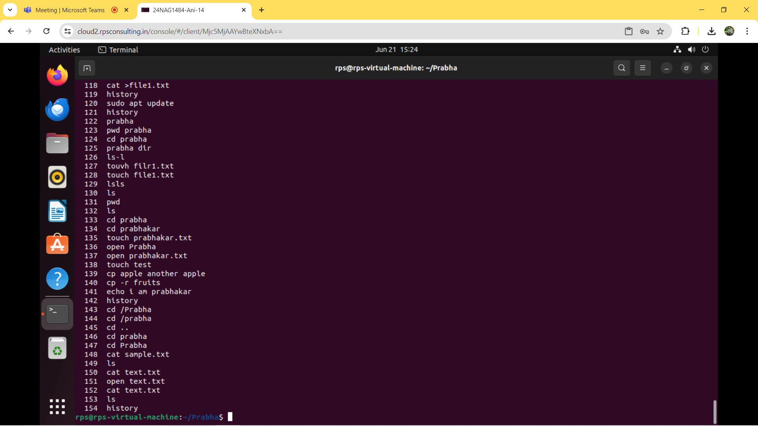

**GitHub Repository link:**

<https://github.com/Prabha3021/Linux>